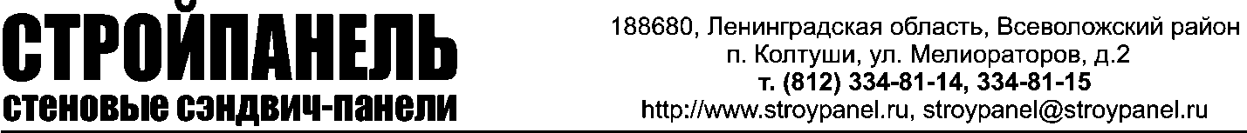

Company details

1 | Company name | LLC "Stroypanel. Tradehouse"
3 | Address | 188680, Leningrad region, Vsevolzhskiy district, Koltushy, v. Aro, 2a
6 | Phone number, fax, email | Tel.: (812) 334-81-13; 14; 15; 16  Fax: (812) 334-81-17  Email: stroypanel@stroypanel.ru
8 | TIN | 7806056160
9 | Tax registration reason code (KPP) | 470301001
14 | Bank account details | Account number 40702810847000001479  Cor. account 30101810900000000790  OJSC “Bank Saint-Petersburg” Proletarski office, Saint-Petersburg  BIK 044030790
15 | Chief executive officer | Gnezdov Aleksander Borisovitch
16 | Chief accountant | Vasilyeva Elena Anatolyevna

